Instructions for Accessing Online Library Resources
- Go to Western’s homepage: http://www.westernseminary.edu/
- Hover over the “Students” tab in the top menu and select “Libraries”
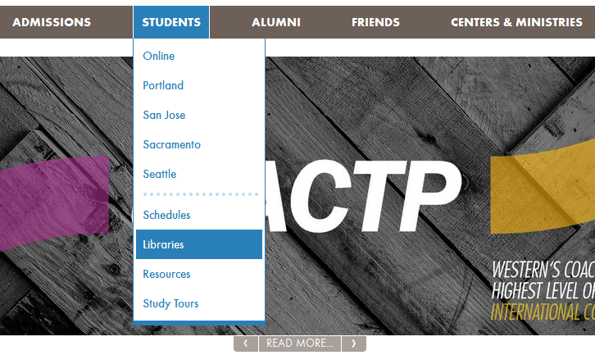

- Select “Library at Corban’s Website”
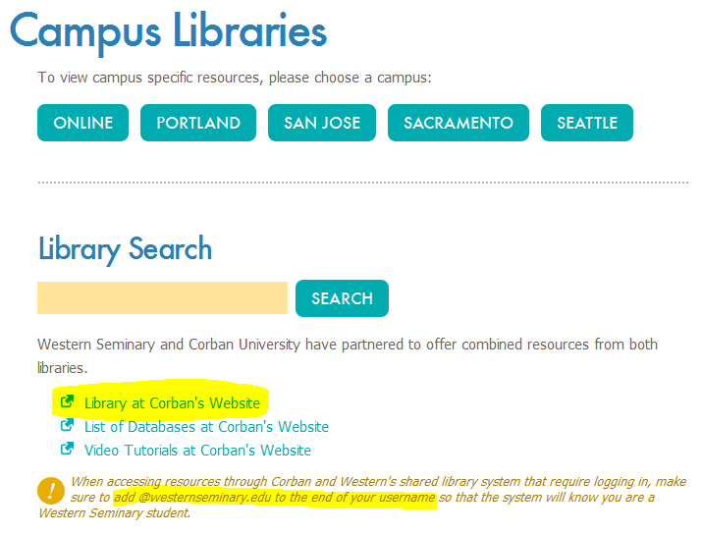
- Or skip steps 1-3 and go directly to https://inside.corban.edu/library
- In the top menu on the right, click “Sign In”
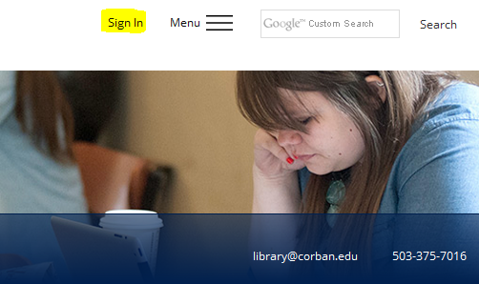

- For your username, enter your SIS username (usually first name + . + last name) and add @westernseminary.edu. The password is your SIS password.
- You now are signed in and have access to our online library resources. You also may request a book through interlibrary loan, in which case you select “Interlibrary Loan” and fill out the request form.
- If you search databases outside of Corban’s, it may look like you’re signed in when you’re actually not. If you notice in the top right that you are currently using the database as “Guest” you will not be able to access much of the content, you will only be able to view the catalog and public domain resources. Be sure to click “Sign In”

- You may also need to create an EBSCO account; that’s free to get, and easy to do, using their ‘create account’ steps.
- If you have questions, feel free to contact us via the www.westernseminary.edu/library website.

